RESULT ANALYSIS REPORT
Academic Year 2024–25 & 2025–26
OVERALL SUMMARY
Programme | Semester | Avg Pass % | Appeared
BSc (Hons) Computer Science | IV Semester | 92.6% | 9
BSc (Hons) Computer Science | II Semester | 93.5% | 8
B.Com (Computer Applications) | IV Semester | 95.0% | 61
B.Com (General) | IV Semester | 100.0% | 12
I B.Com (Computer Applications) | II Semester (2025–26) | 96.0% | 71
I BBA (Honours) | II Semester (2025–26) | 100.0% | 11

PROGRAMME-WISE PASS PERCENTAGE — BAR CHART
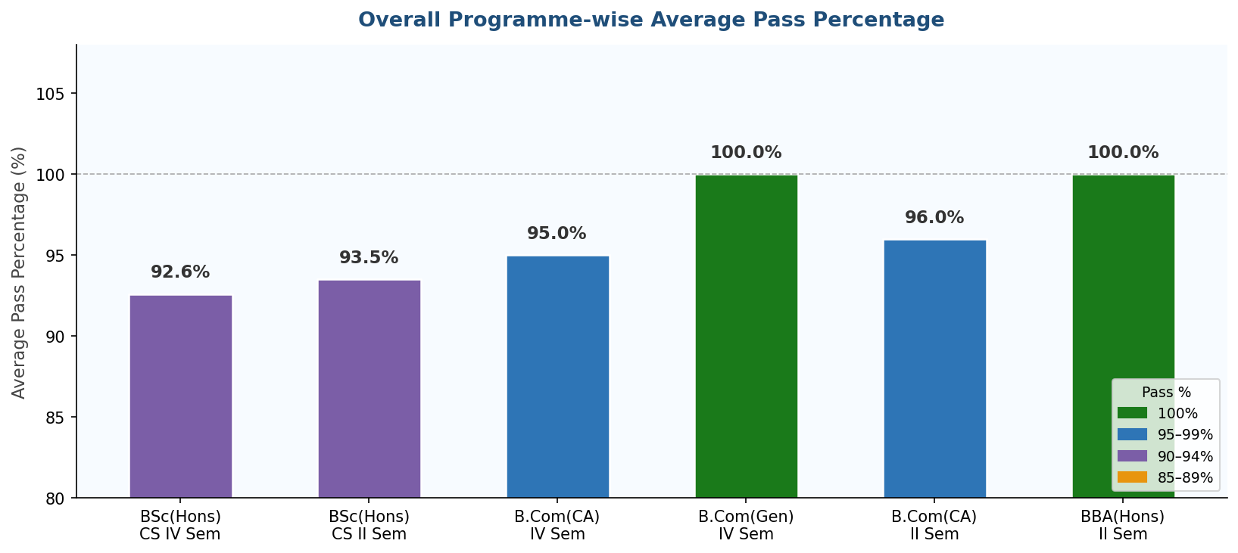
Chart 1: Overall Programme-wise Average Pass Percentage
1. BSc (Honours) Computer Science — IV Semester
Subject | Appeared | Passed | Pass %
Database Management System | 9 | 8 | 88%
Software Engineering | 9 | 9 | 100%
Data Communication & Networks | 9 | 8 | 88%
Problem Solving Using C | 8 | 8 | 100%
Digital Logic Design | 8 | 7 | 87%
Average Pass %: 92.6% | Total Appeared: 9

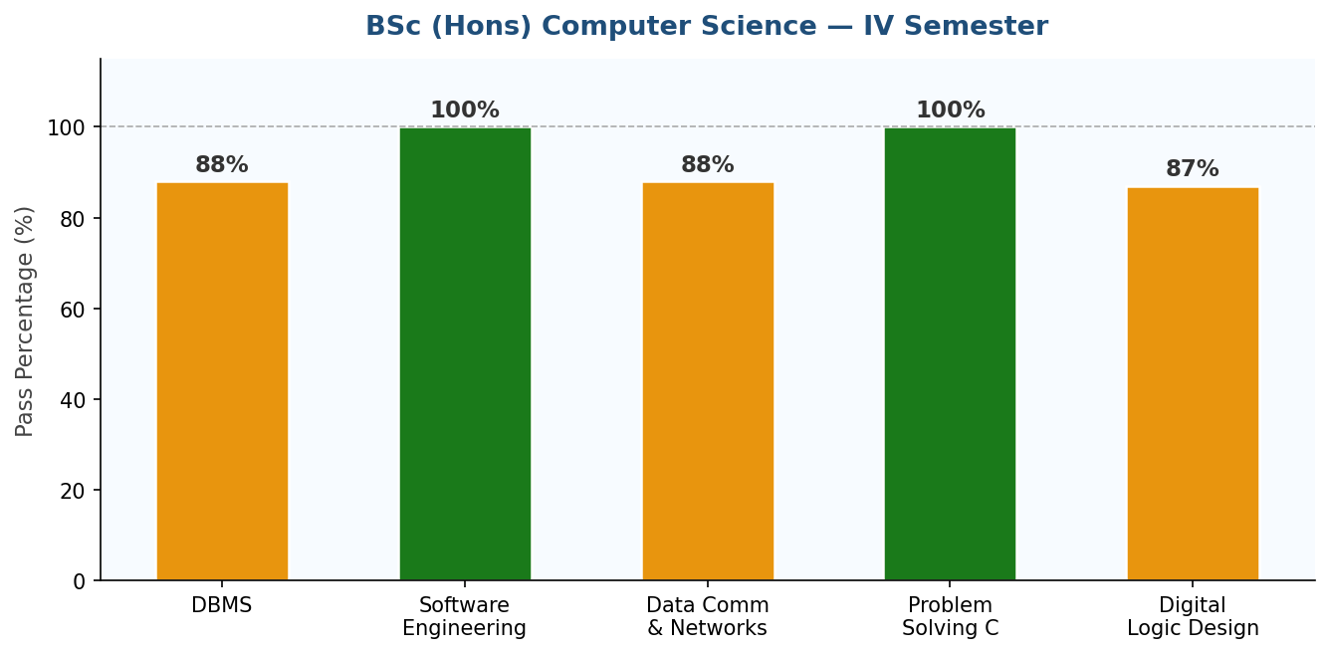
Chart 2: BSc (Hons) CS IV Semester — Subject-wise Pass %
2. BSc (Honours) Computer Science — II Semester
Subject | Appeared | Passed | Pass %
Problem Solving Using C | 8 | 8 | 100%
Digital Logic Design | 8 | 7 | 87%
Average Pass %: 93.5% | Total Appeared: 8

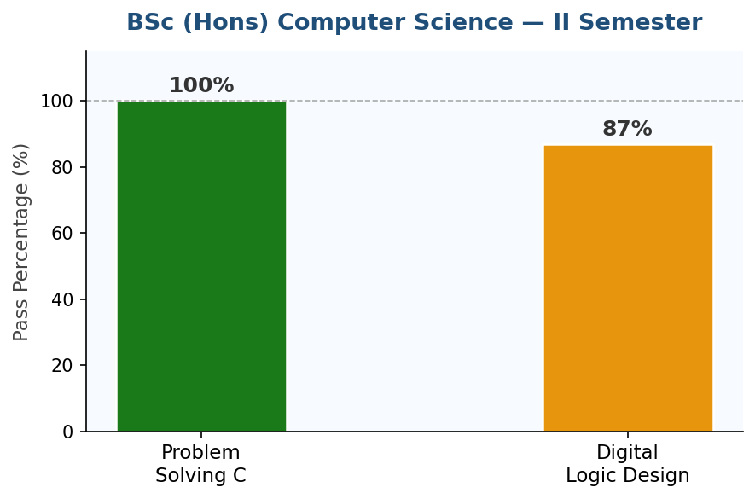
Chart 3: BSc (Hons) CS II Semester — Subject-wise Pass %
3. B.Com (Computer Applications) — IV Semester
Subject | Appeared | Passed | Pass %
Database Management System | 61 | 58 | 95%
Average Pass %: 95.0% | Total Appeared: 61

4. B.Com (General) — IV Semester
Subject | Appeared | Passed | Pass %
Database Management System | 12 | 12 | 100%
Average Pass %: 100.0% | Total Appeared: 12

5. I B.Com (Computer Applications) — II Semester (2025–26)
Subject | Appeared | Passed | Pass %
Office Automation Tools | 71 | 68 | 96%
Average Pass %: 96.0% | Total Appeared: 71

6. I BBA (Honours) — II Semester (2025–26)
Subject | Appeared | Passed | Pass %
Office Automation Tools | 11 | 11 | 100%
Average Pass %: 100.0% | Total Appeared: 11

